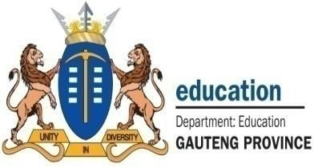


NPO
No: 001041

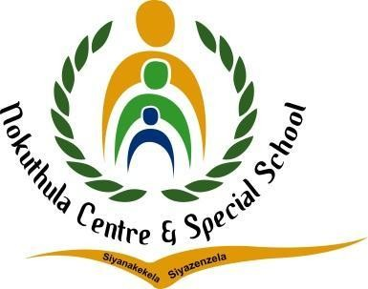
ENGLISH LESSON PLAN

TEL: (011) 444 6443
FAX: (011) 444 6955/2625944
E-MAIL: nokuthulasmh@mweb.co.za

Subject: English |  | Grade: 2 |  | Term: 1 |  |  | Week: 6-7
TOPIC: Me and other people | Content:  - Listening and Speaking  - Phonological/Phonemic Awareness/Phonics  - Emergent Reading  - Shared Reading  - Handwriting and Writing |  | Time allocation:  2 hours daily |  |  | Date started: |  | Date completed:
Prior content knowledge:  - Learners should have prior knowledge about the who she/he is  - Qualities of a good friend and be aware of his/her surroundings.  - Learners interact with the people who help the community e.g., at schools, hospitals etc |  | Lesson objectives: The learners must be able to:  - Identify different people around them, boys and girls  - The learner should be able to differentiate between elders and his/her peers.  - Know the importance of friendship and how to make friends.  - Identify different people who help us with different services in our communities.  - State the services provided by the people in our communities.  - Explain how the services work.  - Explain how the services help or benefit the community  - How to positively deal with conflict and bullying that includes self-esteem. |  |  | Vocabulary/ important words:  - Elders  - Friends  - People  - Bullying  - Self esteem  - Environment  - Gender  - Race  - Conflict |  |  | Teaching strategies:  - Learner centered method  - Question and answer session  - Demonstrating  - Collaboration


Resources:  - Chalkboard  - Chart  - Worksheet  - Big storybook  - Projector | TEACHER’S ACTIVITIES  Listening and Speaking  - The teacher will introduce the lesson by playing a video about different people who offer important services in our communities.  - The teacher will then ask the learners to explain if they are self-aware, and know who they are. Considering their gender.  - The teacher will also discuss how the learners can deal with low self esteem and handle conflict with their peers. | LEARNER’S ACTIVITIES  - Learners will watch the video about different people such s gender and race  - Learners actively participate in the class discussions and ask clarity seeking questions. | Assessment goal: Assessment strategy: Informal  X  Formal    Assessment tool:  - Rubric
 | Phonemic Awareness
 | - Recognize specific identified sight words from the lesson topic.  - Build and blend words with the taught word families.  - Recognize and name the letters of the alphabet. | - Learners actively listen to the ABC songs and try to identify letters of their own names.  - Learners attempt to answer given activities.
 | Reading  - Read a story about the importance of knowing who you are as a child.your place of birth and the importance of respect. | - Learners read Big Book stories with the teacher. Predict what will happen next in the story using pictorial cues.

 | Handwriting and Writing  - Task learners to trace the names and the occupations of the people who help us in our communities.  - Give learners patterns (rounded, pointed, vertical lines), letters and words to trace. | - Learners will trace the names and the occupations of the people who help us in our communities.  - Learners trace patterns, and letters.
Differentiation (Enrichment opportunities/ addressing barriers) |  |  | Practical task
- Group 1: Learners will be given an activity to color the pictures of a certain profession/career e.g. Doctor.  - Group 2: learners will be given an activity to match the pictures of different people and the occupations they work in.  - Group 3: Learners will be given an activity to draw a picture of a profession/career that they like. |  |  | Learners will draw and color different pictures of the careers of their choice.
Teacher reflection: |  |  | Name of Teacher:  Treggy Banda
HOD Input: |  |  | Name of HOD:  Monica Mpande

